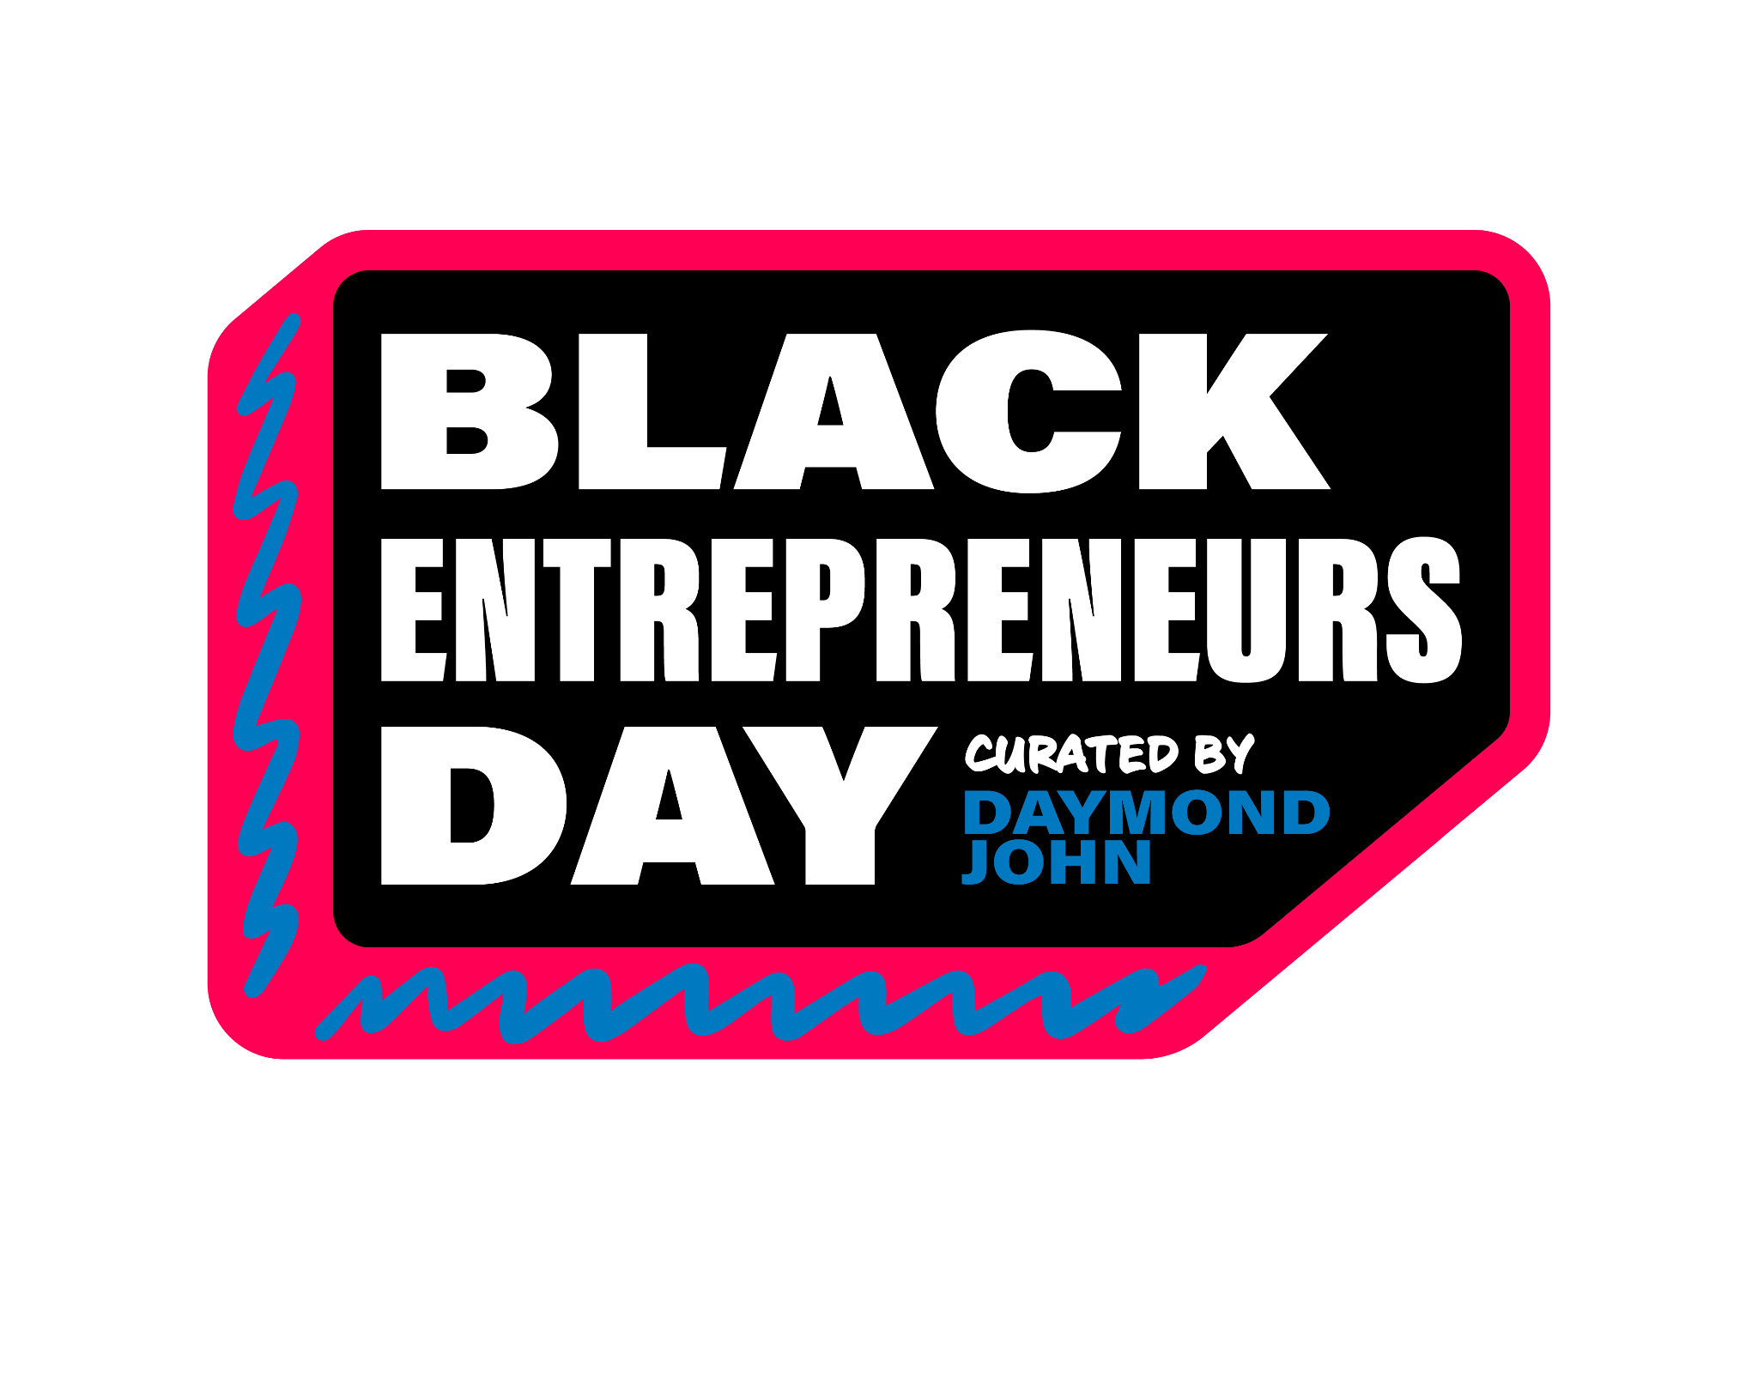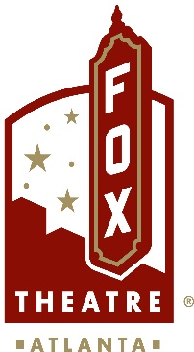  
**For More Information:**Sarah Wynn Benton  
BRAVE Public Relations  
404.233.3993

[sbenton@emailbrave.com](mailto:sbenton@emailbrave.com)

**FOR IMMEDIATE RELEASE**

**Daymond John Announces Fifth Annual Black Entrepreneurs Day: A Celebration   
of Black Excellence and Opportunity**

*To commemorate the anniversary, the event moves to the “Capital of Black Entrepreneurship” on Friday, Nov. 22 at Atlanta’s historic Fox Theatre featuring Kelly Rowland, Charlamagne Tha God, Flavor Flav, Jordan Chiles, a live performance from 2Chainz and more!*

[*'NAACP Powershift Entrepreneur Grant'*](https://app.helloalice.com/grants/naacp-powershift-entrepreneur-grant-2024) *Submissions are Now Open — This Year To Reach $1M+ Distributed in Black Business Grants*

**ATLANTA (Oct. 25, 2024)** – Daymond John, entrepreneur and investor, proudly announces the fifth Annual [Black Entrepreneurs Day](http://blackentrepreneursday.com) (BED), taking place on Friday, Nov. 22 at the iconic Fox Theater in Atlanta – the historic birthplace of the Civil Rights Movement and a thriving hub of Black culture and excellence. This year, BED will be free for all guests to attend and include branded activations as well as light bites and drinks for sale - promising an unforgettable experience that aims to entertain, inform and inspire.

Founded in 2020 in response to the community's challenges following the tragic events surrounding George Floyd, Black Entrepreneurs Day was created to shift the narrative from destruction to empowerment. With a commitment to supporting Black entrepreneurs, the event aims to educate and inspire through conversation with iconic Black leaders and celebrity friends, and will provide essential financial support through its **NAACP Powershift Gran**t program.

Tickets for Black Entrepreneurs Day 2024 are free and available for registration at [BlackentrEpreneursDay.com](https://blackentrepreneursday.com/) now.

**A Star-Studded Experience**

The event will feature engaging conversations with an inspiring lineup of guests, including Grammy-winning artist and philanthropist **Kelly Rowland**; the iconic entertainer **Flavor Flav**, known for his unique blend of humor and cultural influence; influential media personality **Charlamagne tha God**, celebrated for his thought-provoking discussions on social issues; Olympic gymnast **Jordan Chiles** (presented by [J.P. Morgan Wealth Management](https://www.chase.com/personal/investments/business)), a role model of tenacity and excellence; and financial educators **Rashad Bilal** and **Troy Millings** from *Earn Your Leisure*, passionate advocates for financial literacy. Additionally, attendees will be treated to a live performance by the multi-platinum rapper **2Chainz** presented by **Raising Cane’s**. Known for his dynamic style and impactful lyrics, 2 Chainz will energize the audience and celebrate the spirit of entrepreneurship. Attendees will also enjoy the Entrepreneur Plaza pre-event, showcasing brand activations and pop-ups from sponsors. Past Black Entrepreneurs Day guests include Whoopi Goldberg, Spike Lee, Shaquille O’Neal, Kevin Hart, Tyra Banks, Michael Strahan and many more.

**Powershift Grant Program**

Through Nov. 1, entrepreneurs can apply for the Powershift Grant [HERE](http://bedgrant.com). By the conclusion of BED 2024, the initiative will have awarded over $1 million in grants to more than 40 Black-owned businesses, fostering economic growth and innovation in the community. This year, partners **JPMorganChase**, **Hilton**, **T-Mobile for Business** and **Constant Contact** will contribute a total of $100,000 in grants, with each grant amounting to $25,000.

"Atlanta isn’t just a city; it’s the heartbeat of Black culture, entrepreneurship and resilience. When we considered moving Black Entrepreneurs Day from the Apollo, there was no question in our minds—Atlanta is the 'Black Mecca.' It’s where innovation meets history, and it embodies the spirit of empowerment that we celebrate at this event. We’re excited to honor that legacy and inspire the next generation of entrepreneurs right here in the heart of the community,” said Daymond John. “I want to extend my heartfelt gratitude to our partners for their unwavering support of Black businesses; they are truly walking the walk in a time when commitment to diversity and inclusion is more important than ever."

**Key Partners**

**JPMorganChase,** a proud supporter of Black Entrepreneurs Day since its inception five years ago, will return as a prominent sponsor of this year’s event. The firm offers financial tools and resources to help business owners start, run and grow their businesses while working towards their personal financial goals. This year, **JPMorganChase** and [**J.P. Morgan Wealth Management**](https://www.chase.com/personal/investments) will take center stage, powering conversations led by Daymond John with Olympian **Jordan Chiles** and **Lanän Clark**, Regional Director at J.P. Morgan Wealth Management. To learn more about JPMorganChase’s offerings, visit [blackentrepreneursday.com](http://blackentrepreneursday.com/jpmorganchase).

A returning partner and continuous supporter of entrepreneurs, **Hilton** will introduce a new discussion focused on the ways in which the company is dedicated to meeting entrepreneurs where they are, providing them with valuable networking opportunities, travel tools, as well as new business opportunities. As the home away from home for millions of entrepreneurs every day, Hilton takes seriously its commitment to be a powerful engine of opportunity. To learn more about Hilton’s support and travel tools, visit [Hilton for Business.](https://www.hilton.com/en/p/hilton-for-business/)

At Black Entrepreneurs Day, **Constant Contact** will showcase how it helps entrepreneurs succeed by providing them with the marketing tools and guidance they need to build communities, engage with their customers and generate sales. Joining Daymond John on stage for a roundtable conversation will be Constant Contact brand ambassadors Tamika Catchings, a four-time Olympic Gold Medalist, WNBA hall of famer and owner of [Tea’s Me Cafe](https://www.teasmeindy.com/) and Scharrell Jackson, international keynote speaker, executive coach, author and founder of [Leadership in Heels](https://www.scharrelljackson.com/). In addition, Constant Contact will offer professional headshots at the Fox Theatre, helping entrepreneurs elevate their personal branding. To learn more about Constant Contact, visit [ConstantContact.com](https://www.constantcontact.com/?utm_source=brand&utm_medium=referral&utm_campaign=us_f_aw_we_sp_bt_bed&cc=sponsorship_BED_PR).

As a proud returning partner of Black Entrepreneurs Day, **T-Mobile for Business** is excited to join Daymond John for the fifth year of inspiration, education and celebration. This year’s partnership will spotlight the T-Mobile for Business community alongside Daymond, showcasing the journey of entrepreneurship while harnessing the intersection of mobile connectivity and emerging technology to grow and scale business. To learn more about how entrepreneurs can take their business further, visit t-mobile.com.

**America’s Navy** is a new, proud supporter of Black Entrepreneurs Day, showcasing the journeys of Sailors who have successfully transitioned into entrepreneurship. The Navy is the most highly skilled, technologically advanced military force in the world, and attendees will learn about the training and resources available in the Navy that help prepare service members to start and grow their own businesses. Through inspiring stories and interactive exhibits, the Navy aims to highlight the breadth and depth of skills and discipline Sailors bring to the entrepreneurial landscape.

As part of the festivities at Black Entrepreneurs Day, **Raising Cane's**—a brand deeply committed to empowering entrepreneurial efforts across Communities—is proud to present a live performance by acclaimed rapper 2 Chainz. This partnership underscores Raising Cane's dedication to fostering small business growth and entrepreneurship, recognizing their vital role in driving economic development and strengthening local Communities. Through initiatives like these, Raising Cane’s continues to champion opportunities that inspire and uplift future business leaders.

**Lowe’s,** a longtime supporter of entrepreneurship, workforce development, community partnerships and Black Entrepreneurs Day, will host a conversation between Daymond John and Quonta “Que” Vance, Lowe’s Executive Vice President, Pro and Home Services.

**Salesforce,** the No. 1 AI CRM, is a proud sponsor of Black Entrepreneurs Day for the fourth year in a row, helping entrepreneurs and organizations of any size reimagine their business for the world of AI. This year, Daymond John will host “AI for All*,*”a conversation presented by Salesforce that will showcase how Historically Black Colleges and Universities (HBCU) students are gaining AI skills and certifications through Salesforce’s free learning platform, [Trailhead](https://trailhead.salesforce.com/?d=cta-body-promo-8&_ga=2.178527012.145191534.1729096819-1402313654.1696355948&_gac=1.61416926.1728578686.CjwKCAjw9p24BhB_EiwA8ID5BpXVU6O4mawyqTjkOviv-tK4PdRUiDARr8pEPF5QzjCLTFj7e3ghdBoCHuwQAvD_BwE). Check out their [AI for All Announcement](https://www.salesforce.com/news/press-releases/2024/09/18/ai-training-opportunities/) to learn more.

**Join Us - FREE Tickets!**

Don’t miss this landmark event celebrating Black excellence and entrepreneurship. Register for in-person tickets and apply for the NAACP PowerShift Grant at [BlackentrEpreneursDay.com](https://blackentrepreneursday.com/).

**Streaming and Access**

Black Entrepreneurs Day will be live-streamed for free on the Black Entrepreneurs Day website, Daymond John’s Facebook page and across other social media platforms. Budding businesspersons and existing entrepreneurs around the globe can stream the event on [BlackentrEpreneursDay.com](https://blackentrepreneursday.com/) and connect on social channels.

###

**About the Fox Theatre**The Fox Theatre is one of Atlanta's premier venues for live entertainment, welcoming more than 200 performances a year in its 4,665-seat theatre. From concerts to ballets, comedy, and movies, the historic venue attracts more than 500,000 visitors annually. The theatre hosts over 100 annual private events like wedding receptions, trade shows, corporate meetings, and association functions in two fabulous ballrooms. The Fox’s premium Marquee Club, presented by Lexus, is a 10,000 sq. ft, three-story luxury bar accessible to all Club Level ticket holders or annual members of the Fox Theatre. As a 501(c)(3) nonprofit arts organization, the Fox Theatre is a fiercely protected landmark and nationally acclaimed theatre today. The Fox Theatre proudly acknowledges its partners' generous support: Coca-Cola, Georgia Natural Gas, Georgian Terrace Hotel & Livingston Restaurant, Humana, Lexus, Northside Hospital, and Regions Bank. Tickets for all events are available at [FoxTheatre.org](https://protect-us.mimecast.com/s/v0QXCOYoRKcNvKACmEBXS?domain=secure-web.cisco.com), or toll-free at 855-285-8499. Stay connected by following the Fox Theatre on social via @theFoxTheatre on [Instagram](https://protect-us.mimecast.com/s/SE2wCPNp8Li03x4HxEXzY?domain=secure-web.cisco.com), [Twitter](https://protect-us.mimecast.com/s/6oQPCQWqRMHXoW6i7XoPc?domain=secure-web.cisco.com), [and Facebook](https://protect-us.mimecast.com/s/kDgUCR6r7NtG5LrIZrWlF?domain=secure-web.cisco.com).

Notable accolades include 2023 Billboard Magazine #2 Highest Grossing Theatre Worldwide (5,000 seats or less); 2023 VenuesNow Magazine #2 Year-End Top Stops (2,001-5,000 seats); 2022 IEBA Theatre of the Year; 2021 Billboard Magazine #1 Highest Grossing Theatre Worldwide (5,000 seats or less); 2021 Pollstar Magazine #2 Theatre Worldwide in Ticket Sales and 2021 VenuesNow Magazine #2 Year-End Top Stops (2,001-5,000 seats). Additionally, in 2019, the Fox Theatre was honored with the VenuesNow #1 Top Stop of the Decade Award for Tickets Sold, further cementing its reputation as a premier entertainment venue.